Chapter 3 Occupancy Classification and Use
CALIFORNIA BUILDING CODE — MATRIX ADOPTION TABLE
CHAPTER 3 — OCCUPANCY CLASSIFICATION AND USE
(Matrix Adoption Tables are nonregulatory, intended only as an aid to the code user.
See Chapter 1 for state agency authority and building applications.)
Adopting agency | BSC | BSC  -CG | SFM | HCD |  |  | DSA |  |  | OSHPD |  |  |  |  |  |  | BSCC | DPH | AGR | DWR | CEC | CA | SL | SLC
 |  |  |  | 1 | 2 | 1/AC | AC | SS | SS/CC | 1 | 1R | 2 | 3 | 4 | 5 | 6
Adopt entire chapter | X |  |  |  |  |  |  | X | X | X | X | X | X | X | X | X
Adopt entire chapter as  amended (amended  sections listed below) |  |  | X | X | X
Adopt only those sections  that are listed below |  |  |  |  |  |  |  |  |  |  |  |  |  |  |  |  |  |  |  |  | X
Chapter / Section
302.1 |  |  | X | X | X
302.1.3 |  |  |  |  |  |  |  |  |  |  |  |  |  |  |  |  |  |  |  |  | X
303.1 |  |  | X
303.2 |  |  | X
303.7 |  |  | X
303.8 |  |  | X
304.1 |  |  | X
305.1 |  |  | X
305.2 |  |  | X
305.2.1 |  |  | X
306.2 |  |  | X
Table 307.1(1) |  |  | X
Table 307.1(2) |  |  | X
307.1.1 |  |  | X
307.4 |  |  | X
308.1 |  |  | X
308.3 |  |  | X | † | †
308.4 |  |  | X
308.4.6 |  |  | X
308.4.7 |  |  | X
308.4.8 |  |  | X
308.4.9 |  |  | X
308.5 |  |  | X
308.5.2 |  |  | X
308.5.3 |  |  | X
308.5.4 |  |  | X
310.1 |  |  | X
310.2 |  |  | X | X
310.3 |  |  | X | X
310.3.1 |  |  | X
310.3.2 |  |  | X
310.4 |  |  | X | X
310.4.1 |  |  | X
310.4.2 |  |  | X | X | X
310.5 |  |  | X
310.6 |  |  | X
313 |  |  | X
314 |  |  | X
The state agency does not adopt sections identified with the following symbol: †
The Office of the State Fire Marshal's adoption of this chapter or individual sections is applicable to structures regulated by other state agencies pursuant to Section 1.11.
User notes:
About this chapter: Chapter 3 provides the criteria by which buildings and structures are classified into use groups and occupancies. Through the balance of the code, occupancy classification is fundamental in the setting of features of construction; occupant safety requirements, especially building limitations; means of egress; fire protection systems; and interior finishes.
ICC code development note: Code change proposals to sections preceded by the designation [F] will be considered by the IFC code development committee meeting during the 2024 (Group A) Code Development Cycle. All other code change proposals will be considered by a code development committee meeting during the 2025 (Group B) Code Development Cycle.
Section 301 Scope
301.1 General
The provisions of this chapter shall control the classification of all buildings and structures as to occupancy and use. Different classifications of occupancy and use represent varying levels of hazard and risk to building occupants and adjacent properties.
Section 302 Occupancy Classification and Use Designation
302.1 Occupancy Classification
Diagram
Occupancy classification is the formal designation of the primary purpose of the building, structure or portion thereof. Structures shall be classified into one or more of the occupancy groups specified in this section based on the nature of the hazards and risks to building occupants generally associated with the intended purpose of the building or structure. An area, room or space that is intended to be occupied at different times for different purposes shall comply with all applicable requirements associated with such potential multipurpose. Structures containing multiple occupancy groups shall comply with Section 508. Where a structure is proposed for a purpose that is not specified in this section, such structure shall be classified in the occupancy it most nearly resembles based on the fire safety and relative hazard. Occupiable roofs shall be classified in the group that the occupancy most nearly resembles, according to the fire safety and relative hazard, and shall comply with Section 503.1.4.
- Assembly (see Section 303): Groups A-1, A-2, A-3, A-4 and A-5.
- Business (see Section 304): Group B.
- [SFM] Organized Camps (see Section 450): Group C.
- Educational (see Section 305): Group E.
- Factory and Industrial (see Section 306): Groups F-1 and F-2.
- High Hazard (see Section 307): Groups H-1, H-2, H-3, H-4 and H-5.
- Institutional (see Section 308): Groups I-2, I-3 and I-4.
- [SFM] Laboratory (see Section 202): Group B, unless classified as Group L (see Section 453) or Group H (see Section 307).
- [SFM] Laboratory Suites (see Section 453): Group L.
- Mercantile (see Section 309): Group M.
- Residential (see Section 310): Groups R-1, R-2, R-2.1, R-3, R-3.1 and R-4.
- Storage (see Section 311): Groups S-1 and S-2.
- Utility and Miscellaneous (see Section 312): Group U.
- [SFM] Existing buildings housing existing protective social care homes or facilities established prior to 1972 (see California Fire Code Chapter 11 and California Existing Building Code).
UpCodes Diagrams (2)
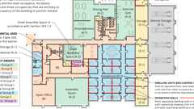
Multiple Occupancy Building: Non-Separated Occupancy Requirements
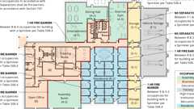
Multiple Occupancy Building: Separated Occupancy Requirements
302.1.1
Reserved
302.1.2
Reserved
302.1.3 Pharmacies; Veterinary Facilities; Barbering, Cosmetology or Electrolysis Establishments; And Acupuncture Offices
See Chapter 12.
302.2 Use Designation
Occupancy groups contain subordinate uses having similar hazards and risks to building occupants. Uses include, but are not limited to, those functional designations specified within the occupancy group descriptions in Section 302.1. Certain uses require specific limitations and controls in accordance with the provisions of Chapter 4 and elsewhere in this code.
Section 303 Assembly Group A
Diagram
UpCodes Diagrams (16)
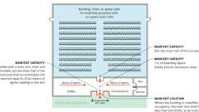
Assembly: Main Exit Provided
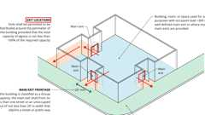
Assembly: No Main Exit or Multiple Exits
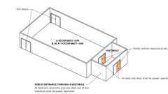
Automatic Doors: When Required
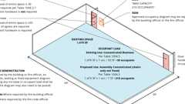
Increased Occupant Load
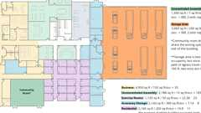
Multiple Occupancy Building: Design Occupant Load
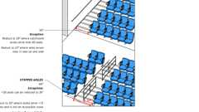
Min. Assembly Aisle Widths
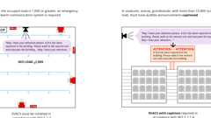
Fire Alarm: Group A Requirements
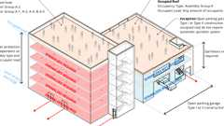
Assembly Occupancies on Roofs
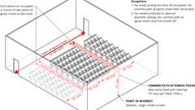
Common Path of Travel from Assembly Seating
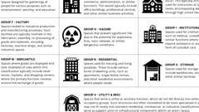
Occupancy Groups of the Building Code
Show 6 more
303.1 Assembly Group A
Assembly Group A occupancy includes, among others, the use of a building or structure, or a portion thereof, for the gathering of persons for purposes such as civic, social or religious functions; recreation, food or drink consumption or awaiting transportation; motion picture and television production studio sound stages, approved production facilities and production locations; or for the showing of motion pictures when an admission fee is charged and when such building or structure is open to the public and has a capacity of 10 or more persons.
303.1.1 Small Buildings and Tenant Spaces
A building or tenant space used for assembly purposes with an occupant load of less than 50 persons shall be classified as a Group B occupancy.
303.1.2 Small Assembly Spaces
Diagram
The following rooms and spaces shall not be classified as Assembly occupancies:
- A room or space used for assembly purposes with an occupant load of less than 50 persons and accessory to another occupancy shall be classified as a Group B occupancy or as part of that occupancy.
- A room or space used for assembly purposes that is less than 750 square feet (70 m²) in area and accessory to another occupancy shall be classified as a Group B occupancy or as part of that occupancy.
UpCodes Diagrams (3)
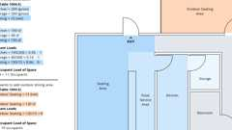
Occupant Load Calc: Small Space
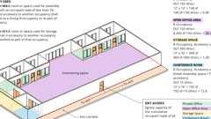
Cumulative Occ. Loads: Intervening Spaces/Accessory Areas
Multiple Occupancy Building: Non-Separated Occupancy Requirements
303.1.3 Associated With Group E Occupancies
Diagram
A room or space used for assembly purposes that is associated with a Group E occupancy is not considered a separate occupancy.
UpCodes Diagram (1)
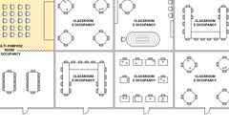Primary
Edu. Accessory to Group A
303.1.4 Accessory to Places of Religious Worship
Diagram
Accessory religious educational rooms and religious auditoriums with occupant loads of less than 100 per room or space are not considered separate occupancies.
UpCodes Diagrams (2)
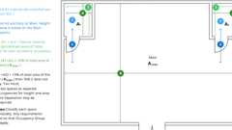
Accessory Occupancies
Edu. Accessory to Group A
303.1.5 Special Amusement Areas
Special amusement areas shall comply with Section 411.
303.2 Assembly Group A-1
Diagram
Group A-1 occupancy includes assembly uses, usually with fixed seating, intended for the production and viewing of the performing arts or motion pictures, including but not limited to:
- Motion picture and television production studio sound stages, approved production facilities and production locations. (with live audiences).
- Motion picture theaters
- Symphony and concert halls
- Television and radio studios admitting an audience
- Theaters
UpCodes Diagrams (5)
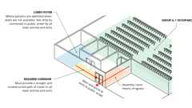
Foyers and Lobbies (Group A-1) Pt 2
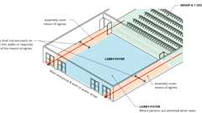
Foyers and Lobbies (Group A-1) Pt 1
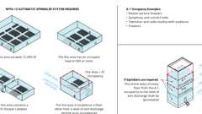
Sprinklers: Group A-1
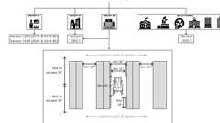
Aisle Req. by Occ. Group
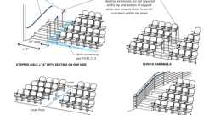
Handrails at Aisles: Assembly
303.3 Assembly Group A-2
Diagram
Group A-2 occupancy includes assembly uses intended for food and/or drink consumption, including but not limited to:
- Banquet halls
- Casinos (gaming areas)
- Nightclubs
- Restaurants, cafeterias and similar dining facilities (including associated commercial kitchens)
- Taverns and bars
UpCodes Diagrams (8)
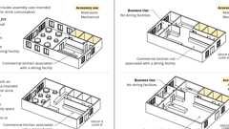Primary
Commercial Kitchens: Occupancy
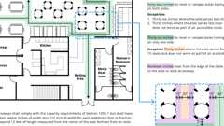
Aisles with Tables and Fixtures
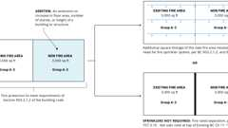
Fire Areas: Additions to Buildings
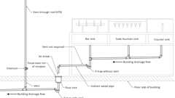
Vents Not Required: Bars, Soda Fountains, and Counter
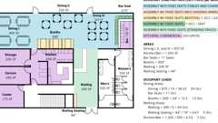
Occupant Load: Multiple Function Spaces
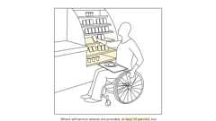
Food Service: Self-Service Shelves
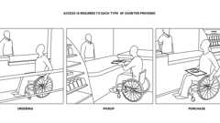
Food Service Counters (ADA)
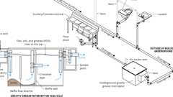
Grease Interceptors (UPC)
303.4 Assembly Group A-3
Diagram
Group A-3 occupancy includes assembly uses intended for worship, recreation or amusement and other assembly uses not classified elsewhere in Group A, including but not limited to:
- Amusement arcades
- Art galleries
- Bowling alleys
- Community halls
- Courtrooms
- Dance halls (not including food or drink consumption)
- Exhibition halls
- Funeral parlors
- Greenhouses for the conservation and exhibition of plants that provide public access
- Gymnasiums (without spectator seating)
- Indoor swimming pools (without spectator seating)
- Indoor tennis courts (without spectator seating)
- Lecture halls
- Libraries
- Museums
- Places of religious worship
- Pool and billiard parlors
- Waiting areas in transportation terminals
UpCodes Diagrams (4)
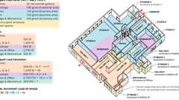
Occupant Load Calc: Gallery
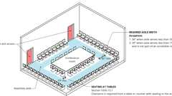
Aisles at Tables or Seats: Assembly Occ.
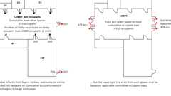
Exits through Lobbies
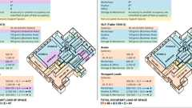
Occupancy Groups: Art Studios
Building products (4)
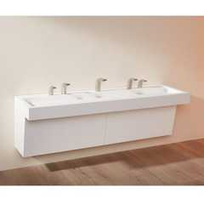
Monolith A Series - TSL.MON.A
The Splash Lab

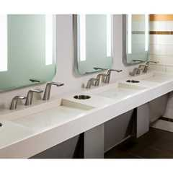
Monolith B Series - TSL.MON.B
The Splash Lab

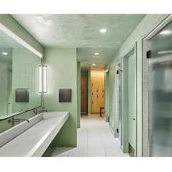
Monolith C Series - TSL.MON.C
The Splash Lab

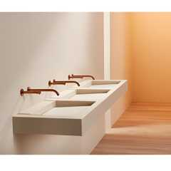
Monolith D Series - TSL.MON.D
The Splash Lab

303.5 Assembly Group A-4
Diagram
Group A-4 occupancy includes assembly uses intended for viewing of indoor sporting events and activities with spectator seating, including but not limited to:
- Arenas
- Skating rinks
- Swimming pools
- Tennis courts
UpCodes Diagrams (3)
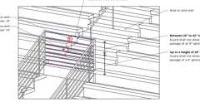
Guardrail Opening Limitations (Ex. 5)
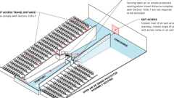
Exit Access Stair: Enclosure (Ex. 7)
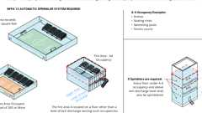
Sprinklers: Group A-4
Building products (9)
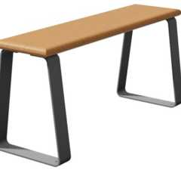
Benches
Hadrian Solutions ULC

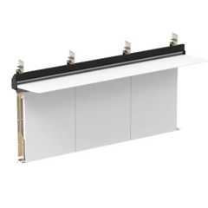
Integrated Plumbing System / Aerofoil - TSL.IPS.AERO
The Splash Lab

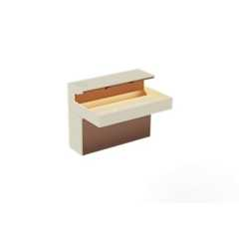
Lumashelf Integrated Sink - TSL.LUMA
The Splash Lab

Monolith A Series - TSL.MON.A
The Splash Lab

Monolith B Series - TSL.MON.B
The Splash Lab

Monolith C Series - TSL.MON.C
The Splash Lab

Monolith D Series - TSL.MON.D
The Splash Lab

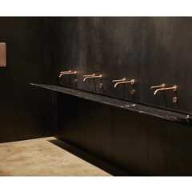
The Aerofoil Basin - TSL.AERO
The Splash Lab

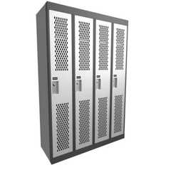
​​Athletic (Gladiator) Lockers
Hadrian Solutions ULC

303.6 Assembly Group A-5
Diagram
Group A-5 occupancy includes assembly uses intended for participation in or viewing outdoor activities, including but not limited to:
- Amusement park structures
- Bleachers
- Grandstands
- Stadiums
UpCodes Diagrams (4)
Guardrail Opening Limitations (Ex. 5)
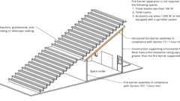
Spaces Under Bleachers
Exit Access Stair: Enclosure (Ex. 7)
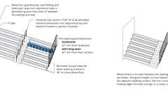
Perimeter Guards at Assembly Seating
Building products (9)
Benches
Hadrian Solutions ULC

Integrated Plumbing System / Aerofoil - TSL.IPS.AERO
The Splash Lab

Lumashelf Integrated Sink - TSL.LUMA
The Splash Lab

Monolith A Series - TSL.MON.A
The Splash Lab

Monolith B Series - TSL.MON.B
The Splash Lab

Monolith C Series - TSL.MON.C
The Splash Lab

Monolith D Series - TSL.MON.D
The Splash Lab

The Aerofoil Basin - TSL.AERO
The Splash Lab

​​Athletic (Gladiator) Lockers
Hadrian Solutions ULC

303.7 Fixed Guideway Transit Systems
[SFM] Fixed guideway transit system buildings shall conform to the requirements of this code for their occupancy classification in addition to the provisions set forth in Section 443.
303.8 Subterranean Spaces for Winery Facilities in Natural or Manmade Caves
[SFM] For fire and life safety requirements, see Section 446.
Section 304 Business Group B
Diagram
UpCodes Diagrams (12)
Primary
Commercial Kitchens: Occupancy
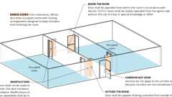
Locking Arrangements in Educational Occupancies
Automatic Doors: When Required
Multiple Occupancy Building: Design Occupant Load
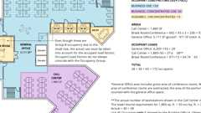
Occ. Loads: Business and Concentrated Business Use
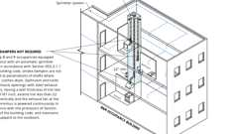
Shafts: Duct & Air Transfer Opening Penetrations - Excpt. 2
Occupancy Groups of the Building Code
Occupancy Groups: Art Studios
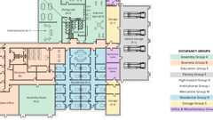
Multiple Occupancy Building - Occupancy Groups
Multiple Occupancy Building: Non-Separated Occupancy Requirements
Show 2 more
304.1 Business Group B
Diagram
Business Group B occupancy includes, among others, the use of a building or structure, or a portion thereof, for office, professional or service-type transactions, including storage of records and accounts. Business occupancies shall include, but not be limited to, the following:
- Airport traffic control towers
- Ambulatory care facilities
- Animal hospitals, kennels and pounds
- Banks
- Barber and beauty shops
- Car wash
- Civic administration
- Clinic, outpatient
- Dry cleaning and laundries: pick-up and delivery stations and self-service
- Educational occupancies for students above the 12th grade including higher education laboratories
- Electronic data entry
- Food processing establishments and commercial kitchens not associated with restaurants, cafeterias and similar dining facilities not more than 2,500 square feet (232 m²) in area
- Laboratories: testing and research and [SFM] instruction
- Lithium-ion or lithium metal battery testing, research and development
- Motor vehicle showrooms
- Post offices
- Print shops
- Professional services (architects, attorneys, dentists, physicians, engineers, etc.)
- Radio and television stations
- Telephone exchanges
- Training and skill development not in a school or academic program (this shall include, but not be limited to, tutoring centers, martial arts studios, gymnastics and similar uses regardless of the ages served, and where not classified as a Group A occupancy)
UpCodes Diagrams (4)
Cumulative Occ. Loads: Intervening Spaces/Accessory Areas
Increased Occupant Load
Commercial Kitchens: Occupancy
Grease Interceptors (UPC)
Building products (8)
Integrated Plumbing System / Aerofoil - TSL.IPS.AERO
The Splash Lab

Lumashelf Integrated Sink - TSL.LUMA
The Splash Lab

Monolith A Series - TSL.MON.A
The Splash Lab

Monolith B Series - TSL.MON.B
The Splash Lab

Monolith C Series - TSL.MON.C
The Splash Lab

Monolith D Series - TSL.MON.D
The Splash Lab

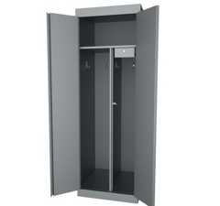
Specialty Lockers
Hadrian Solutions ULC

The Aerofoil Basin - TSL.AERO
The Splash Lab

304.2 Airport Traffic Control Towers
Airport traffic control towers shall comply with Section 412.2.
304.3 Ambulatory Care Facilities
Diagram
Ambulatory care facilities shall comply with Section 422.
UpCodes Diagram (1)
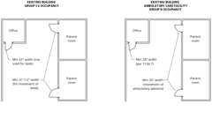
Existing Bldgs: Min. Door Reqs. - Healthcare
Section 305 Educational Group E
Diagram
UpCodes Diagrams (4)
Locking Arrangements in Educational Occupancies
Occupancy Groups of the Building Code
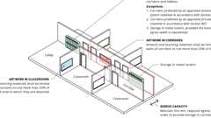
Decorative Materials: Group E
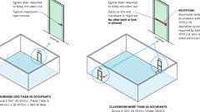
Alterations: Locking Arrangements in Educational Occupancies
305.1 Educational Group E
Educational Group E occupancy includes, among others, the use of a building or structure, or a portion thereof, more than six persons at any one time for educational purposes through the 12th grade.
Exception: [SFM] A residence used as a home school for the children who normally reside at the residence. Such residences shall remain classified as Group R-2, or Group R-3 occupancies.
Building product (1)
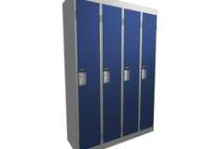
Corridor (Emperor) Lockers
Hadrian Solutions ULC

305.1.1 Accessory to Places of Religious Worship
Diagram
Religious educational rooms and religious auditoriums, which are accessory to places of religious worship in accordance with Section 303.1.4 and have occupant loads of less than 100 per room or space, shall be classified as Group A-3 occupancies.
UpCodes Diagrams (2)
Accessory Occupancies
Edu. Accessory to Group A
305.2 Group E, Child-Care Facilities
This group includes buildings and structures or portions thereof occupied by more than six children 36 months of age and older who receive educational, supervision or personal care services for fewer than 24 hours per day.
Exception: [SFM] A child-care facility not otherwise classified a Group R-3 occupancy, where occupants are not capable of responding to an emergency situation without physical assistance from the staff shall be classified as Group I-4. Infants and toddlers are allowed in a Group E child care when the facility complies with California Building Code Section 305.2.1, 305.2.2, 305.2.3 or 308.5.1.
305.2.1 Within Places of Religious Worship
Rooms and spaces within places of religious worship providing such child care during religious functions shall be classified as part of the primary occupancy where not licensed for child-care purposes by the Department of Social Services.
305.2.2 Five or Fewer Children
A facility having five or fewer children receiving such day care shall be classified as part of the primary occupancy.
305.2.3 Five or Fewer Children in a Dwelling Unit
A facility such as the above within a dwelling unit and having five or fewer children receiving such day care shall be classified as a Group R-3 occupancy or shall comply with the California Residential Code.
305.3 Storm Shelters in Group E Occupancies
Storm shelters shall be provided for Group E occupancies where required by Section 423.5.
Section 306 Factory Group F
Assembly
Diagram
UpCodes Diagrams (6)
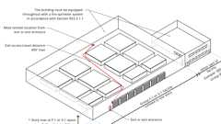
Travel Distance Increase: Group F-1 and S-1
Occupancy Groups of the Building Code
Occupancy Groups: Art Studios
Multiple Occupancy Building - Occupancy Groups
Multiple Occupancy Building: Non-Separated Occupancy Requirements
Multiple Occupancy Building: Separated Occupancy Requirements
Assemblies (2)
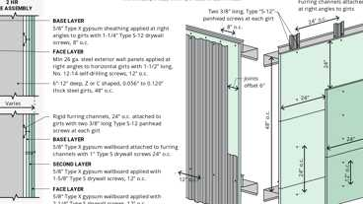
WP 9200; 2hr, Steel Wall Panel / Girts
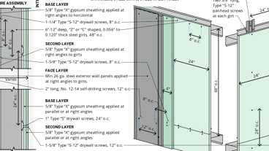
WP 9205; 2hr, Steel Wall Panel / Girts
Building product (1)
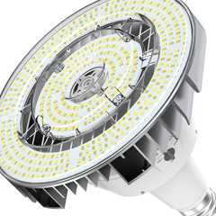
High Bay Bluetooth-enabled
RAB Lighting

306.1 Factory Industrial Group F
Diagram
Factory Industrial Group F occupancy includes, among others, the use of a building or structure, or a portion thereof, for assembling, disassembling, fabricating, finishing, manufacturing, packaging, repair or processing operations that are not classified as a Group H hazardous or Group S storage occupancy.
UpCodes Diagram (1)
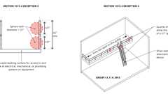
Guardrail Openings - Exceptions 3 & 4
306.2 Moderate-Hazard Factory Industrial, Group F-1
Diagram
Factory industrial uses that are not classified as Factory Industrial F-2 Low Hazard shall be classified as F-1 Moderate Hazard and shall include, but not be limited to, the following:
- Aircraft (manufacturing, not to include repair)
- Appliances
- Athletic equipment
- Automobiles and other motor vehicles
- Bakeries
- Beverages: over 20-percent alcohol content
- Bicycles
- Boats
- Brooms or brushes
- Business machines
- Cameras and photo equipment
- Canvas or similar fabric
- Carpets and rugs (includes cleaning)
- Clothing
- Construction and agricultural machinery
- Disinfectants
- Dry cleaning and dyeing
- Electric generation plants
- Electronics
- Energy storage systems (ESS) in dedicated use buildings
- Energy storage systems (ESS) and equipment containing lithium-ion or lithium metal batteries
- Engines (including rebuilding)
- Food processing establishments and commercial kitchens not associated with restaurants, cafeterias and similar dining facilities more than 2,500 square feet (232 m²) in area
- Furniture
- Hemp products
- Jute products
- Laundries
- Leather products
- Lithium-ion batteries
- Machinery
- Metals
- Millwork (sash and door)
- [SFM] Motion picture and television production studio Sound Stages, Approved Production Facilities and production locations (without live audiences)
- Motion pictures and television filming (without spectators)
- Musical instruments
- Optical goods
- Paper mills or products
- Photographic film
- Plastic products
- Printing or publishing
- Recreational vehicles
- Refuse incineration
- Shoes
- Soaps and detergents
- Textiles
- Tobacco
- Trailers
- Upholstering
- Vehicles powered by lithium-ion or lithium metal batteries
- Water/sewer treatment facilities
- Wood; distillation
- Woodworking (cabinet)
UpCodes Diagrams (5)
Primary
Commercial Kitchens: Occupancy
Travel Distance Increase: Group F-1 and S-1
Multiple Occupancy Building: Design Occupant Load
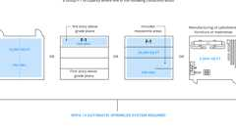
Sprinklers: Group F-1
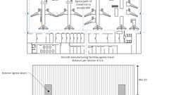
Aircraft Manuf.: Exit Access Travel Dist.
306.2.1 Aircraft Manufacturing Facilities
Aircraft manufacturing facilities shall comply with Section 412.6.
306.3 Low-Hazard Factory Industrial, Group F-2
Diagram
Factory industrial uses that involve the fabrication or manufacturing of noncombustible materials that during finishing, packing or processing do not involve a significant fire hazard shall be classified as Group F-2 occupancies and shall include, but not be limited to, the following:
- Beverages: up to and including 20-percent alcohol content
- Brick and masonry
- Ceramic products
- Foundries
- Glass products
- Gypsum
- Ice
- Metal products (fabrication and assembly)
UpCodes Diagram (1)
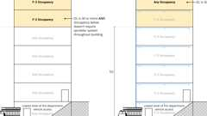
Sprinklers: Bldgs > 55 ft. (Ex. 2)
Section 307 High-Hazard Group H
Diagram
UpCodes Diagrams (6)
Guardrail Openings - Exceptions 3 & 4
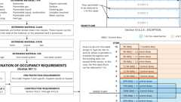
Hazmat Control Areas
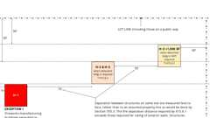
Fire Separation Distance: Group H
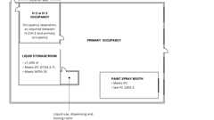
Unlimited Area Exception: Group H
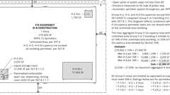
Unlimited Bldg Area: Group H-2, H-3 and H-4 Occs.
Occupancy Groups of the Building Code
[F] 307.1 High-Hazard Group H
High-hazard Group H occupancy includes, among others, the use of a building or structure, or a portion thereof, that involves the manufacturing, processing, generation or storage of materials that constitute a physical or health hazard in quantities in excess of those allowed in control areas complying with Section 414, based on the maximum allowable quantity limits for control areas set forth in Tables 307.1(1) and 307.1(2). Hazardous occupancies are classified in Groups H-1, H-2, H-3, H-4 and H-5 and shall be in accordance with this section, the requirements of Section 415 and the California Fire Code. Hazardous materials stored or used on top of roofs or canopies shall be classified as rooftop storage or use and shall comply with the California Fire Code.
[F] TABLE 307.1(1)—MAXIMUM ALLOWABLE QUANTITY PER CONTROL AREA OF HAZARDOUS MATERIALS POSING A PHYSICAL HAZARD^{a, i, l, m}
MATERIAL | CLASS | GROUP WHEN  THE MAXIMUM  ALLOWABLE  QUANTITY IS  EXCEEDED | STORAGE^{b} |  |  | USE-CLOSED SYSTEMS^{b} |  |  | USE-OPEN SYSTEMS^{b}
MATERIAL | CLASS | GROUP WHEN  THE MAXIMUM  ALLOWABLE  QUANTITY IS  EXCEEDED | Solid pounds  (cubic feet) | Liquid  gallons  (pounds) | Gas (cubic  feet at NTP) | Solid  pounds  (cubic feet) | Liquid  gallons  (pounds) | Gas (cubic  feet at NTP) | Solid  pounds  (cubic feet) | Liquid  gallons  (pounds)
Combustible dust | NA | H-2 | See  Note o | NA | NA | See  Note o | NA | NA | See  Note o | NA
Combustible fiber º | Loose | H-3 | (100) | NA | NA | (100) | NA | NA | (20) | NA
Combustible fiber º | Baled | H-3 | (1,000) | NA | NA | (1,000) | NA | NA | (200) | NA
Combustible liquid^{n} | II | H-2 or H-3 | NA | 120^{d, e} | NA | NA | 120^{d} | NA | NA | 30^{d}
Combustible liquid^{n} | IIIA | H-2 or H-3 | NA | 330^{d, e} | NA | NA | 330^{d} | NA | NA | 80^{d}
Combustible liquid^{n} | IIIB | NA | NA | 13,200^{e, f} | NA | NA | 13,200^{f} | NA | NA | 3,300^{f}
Cryogenic flammable | NA | H-2 | NA | 45^{d} | NA | NA | 45^{d} | NA | NA | 10^{d}
Cryogenic inert | NA | NA | NA | NA | NL | NA | NA | NL | NA | NA
Cryogenic oxidizing | NA | H-3 | NA | 45^{d} | NA | NA | 45^{d} | NA | NA | 10^{d}
Explosives | Division 1.1 | H-1 | 1^{e, g} | (1)^{e, g} | NA | 0.25^{g} | (0.25)^{g} | NA | 0.25^{g} | (0.25)^{g}
Explosives | Division 1.2 | H-1 | 1^{e, g} | (1)^{e, g} | NA | 0.25^{g} | (0.25)^{g} | NA | 0.25^{g} | (0.25)^{g}
Explosives | Division 1.3 | H-1 or H-2 | 5^{e, g} | (5)^{e, g} | NA | 1^{g} | (1)^{g} | NA | 1^{g} | (1)^{g}
Explosives | Division 1.4 | H-3 | 50^{e, g} | (50)^{e, g} | NA | 50^{g} | (50)^{g} | NA | NA | NA
Explosives | Division 1.4G | H-3 | 125^{e, k} | NA | NA | NA | NA | NA | NA | NA
Explosives | Division 1.5 | H-1 | 1^{e, g} | (1)^{e, g} | NA | 0.25^{g} | (0.25)^{g} | NA | 0.25^{g} | (0.25)^{g}
Explosives | Division 1.6 | H-1 | 1^{e, g} | NA | NA | NA | NA | NA | NA | NA
Flammable gas | Gaseous 1A (High BV)^{p} | H-2 | NA | NA | 1,000^{d, e} | NA | NA | 1,000^{d, e} | NA | NA
Flammable gas | Gaseous 1B (High BV)^{p}
Flammable gas | Gaseous 1B (Low BV)^{p} | H-2 | NA | NA | 162,500^{d, e} | NA | NA | 162,500^{d, e} | NA | NA
Flammable gas | Liquefied 1A (High BV)^{p} | H-2 | NA | (150)^{d, e} | NA | NA | (150)^{d, e} | NA | NA | NA
Flammable gas | Liquefied 1B (High BV)^{p}
Flammable gas | 1B (Low BV)^{p} | H-2 | NA | (10,000)^{d, e} | NA | NA | (10,000)^{d, e} | NA | NA | NA
Flammable liquid ^{n} | IA | H-2 or H-3 | NA | 30^{d, e} | NA | NA | 30^{d} | NA | NA | 10^{d}
Flammable liquid ^{n} | IB and IC | H-2 or H-3 | NA | 120^{d, e} | NA | NA | 120^{d} | NA | NA | 30^{d}
Flammable liquid, combination (IA, IB, IC)^{n} | NA | H-2 or H-3 | NA | 120^{d, e, h} | NA | NA | 120^{d, h} | NA | NA | 30^{d, h}
Flammable solid | NA | H-3 | 125^{d, e} | NA | NA | 125^{d} | NA | NA | 25^{d} | NA
Inert gas | Gaseous | NA | NA | NA | NL | NA | NA | NL | NA | NA
Inert gas | Liquefied | NA | NA | NA | NL | NA | NA | NL | NA | NA
Organic peroxide | UD | H-1 | 1^{e, g} | (1)^{e, g} | NA | 0.25^{g} | (0.25)^{g} | NA | 0.25^{g} | (0.25)^{g}
Organic peroxide | I | H-2 | 5^{d, e} | (5)^{d, e} | NA | 1^{d} | (1)^{d} | NA | 1^{d} | (1)^{d}
Organic peroxide | II | H-3 | 50^{d, e} | (50)^{d, e} | NA | 50^{d} | (50)^{d} | NA | 10^{d} | (10)^{d}
Organic peroxide | III | H-3 | 125^{d, e} | (125)^{d, e} | NA | 125^{d} | (125)^{d} | NA | 25^{d} | (25)^{d}
Organic peroxide | IV | NA | NL | NL | NA | NL | NL | NA | NL | NL
Organic peroxide | V | NA | NL | NL | NA | NL | NL | NA | NL | NL
Oxidizer | 4 | H-1 | 1^{g} | (1)^{e, g} | NA | 0.25^{g} | (0.25)^{g} | NA | 0.25^{g} | (0.25)^{g}
Oxidizer | 3^{j} | H-2 or H-3 | 10^{d, e} | (10)^{d, e} | NA | 2^{d} | (2)^{d} | NA | 2^{d} | (2)^{d}
Oxidizer | 2 | H-3 | 250^{d, e} | (250)^{d, e} | NA | 250^{d} | (250)^{d} | NA | 50^{d} | (50)^{d}
Oxidizer | 1 | NA | 4,000^{e, f} | (4,000)^{e, f} | NA | 4,000^{f} | (4,000)^{f} | NA | 1,000^{f} | (1,000)^{f}
Oxidizing gas | Gaseous | H-3 | NA | NA | 1,500^{d, e} | NA | NA | 1,500^{d, e} | NA | NA
Oxidizing gas | Liquefied | H-3 | NA | (150)^{d, e} | NA | NA | (150)^{d, e} | NA | NA | NA
Pyrophoric | NA | H-2 | 4^{e, g} | (4)^{e, g} | 50^{e, g} | 1^{g} | (1)^{g} | 10^{e, g} | 0 | 0
Unstable (reactive) | 4 | H-1 | 1^{e, g} | (1)^{e, g} | 10^{e, g} | 0.25^{g} | (0.25)^{g} | 2^{e, g} | 0.25^{g} | (0.25)^{g}
Unstable (reactive) | 3 | H-1 or H-2 | 5^{d, e} | (5)^{d, e} | 50^{d, e} | 1^{d} | (1)^{d} | 10^{d, e} | 1^{d} | (1)^{d}
Unstable (reactive) | 2 | H-3 | 50^{d, e} | (50)^{d, e} | 750^{d, e} | 50^{d} | (50)^{d} | 750^{d, e} | 10^{d} | (10)^{d}
Unstable (reactive) | 1 | NA | NL | NL | NL | NL | NL | NL | NL | NL
Water reactive | 3 | H-2 | 5^{d, e} | (5)^{d, e} | NA | 5^{d} | (5)^{d} | NA | 1^{d} | (1)^{d}
Water reactive | 2 | H-3 | 50^{d, e} | (50)^{d, e} | NA | 50^{d} | (50)^{d} | NA | 10^{d} | (10)^{d}
Water reactive | 1 | NA | NL | NL | NA | NL | NL | NA | NL | NL
For SI: 1 cubic foot = 0.028 m³, 1 pound = 0.454 kg, 1 gallon = 3.785 L.
NL = Not Limited; NA = Not Applicable; UD = Unclassified Detonable.
- For use of control areas, see Section 414.2.
- The aggregate quantity in use and storage shall not exceed the maximum allowable quantity for storage, including applicable increases.
- Reserved.
- [SFM] In other than Group L occupancies, maximum allowable quantities shall be increased 100 percent in buildings equipped throughout with an automatic sprinkler system in accordance with Section 903.3.1.1. Where Note e also applies, the increase for both notes shall be applied accumulatively.
- Maximum allowable quantities shall be increased 100 percent when stored in approved storage cabinets, day boxes, gas cabinets, gas rooms or exhausted enclosures or in listed safety cans in accordance with Section 5003.9.10 of the California Fire Code. Where Note d also applies, the increase for both notes shall be applied accumulatively.
- Quantities shall not be limited in a building equipped throughout with an automatic sprinkler system in accordance with Section 903.3.1.1.
- Allowed only in buildings equipped throughout with an automatic sprinkler system in accordance with Section 903.3.1.1.
- Containing not more than the maximum allowable quantity per control area of Class IA, IB or IC flammable liquids.
- Quantities in parentheses indicate quantity units in parentheses at the head of each column.
- A maximum quantity of 220 pounds of solid or 22 gallons of liquid Class 3 oxidizers is allowed when such materials are necessary for maintenance purposes, operation or sanitation of equipment when the storage containers and the manner of storage are approved.
- Net weight of the pyrotechnic composition of the fireworks. Where the net weight of the pyrotechnic composition of the fireworks is not known, 25 percent of the gross weight of the fireworks, including packaging, shall be used.
- For gallons of liquids, divide the amount in pounds by 10 in accordance with Section 5003.1.2 of the California Fire Code.
- For oxidizers, unstable (reactive) materials, and water-reactive materials stored or displayed in Group M occupancies or stored in Group S occupancies, see Section 414.2.5.1.
- For flammable and combustible liquid storage in Group M occupancy wholesale and retail sales uses, see Section 414.2.5.2.
- Where manufactured, generated or used in such a manner that the concentration and conditions create a fire or explosion hazard based on information prepared in accordance with Section 414.1.3.
- High Burning Velocity (High BV) Category 1B flammable gas has a burning velocity greater than 3.9 inches per second (10 cm/s). Low Burning Velocity (Low BV) Category 1B flammable gas has a burning velocity of 3.9 inches per second (10 cm/s) or less.
[F] TABLE 307.1(2)—MAXIMUM ALLOWABLE QUANTITY PER CONTROL AREA OF HAZARDOUS MATERIALS POSING A HEALTH HAZARD^{a, h, i}
MATERIAL | STORAGE^{b} |  |  | USE-CLOSED SYSTEMS^{b} |  |  | USE-OPEN SYSTEMS^{b}
MATERIAL | Solid pounds^{d, e, f} | Liquid gallons  (pounds)^{d, e, f} | Gas cubic feet at  NTP (pounds)^{d} | Solid pounds^{d} | Liquid gallons  (pounds)^{d} | Gas cubic feet at  NTP (pounds)^{d} | Solid pounds^{d} | Liquid gallons  (pounds)^{d}
Corrosives | 5,000 | 500 | Gaseous 810e | 5,000 | 500 | Gaseous 810e | 1,000 | 100
Corrosives | 5,000 | 500 | Liquefied (150) | 5,000 | 500 | Liquefied (150) | 1,000 | 100
Highly Toxic | 10 | (10) | Gaseous 20^{g} | 10 | (10) | Gaseous 20^{g} | 3 | (3)
Highly Toxic | 10 | (10) | Liquefied (4)^{g} | 10 | (10) | Liquefied (4)^{g} | 3 | (3)
Toxic | 500 | (500) | Gaseous 810e | 500 | (500) | Gaseous 810e | 125 | (125)
Toxic | 500 | (500) | Liquefied (150)^{e} | 500 | (500) | Liquefied (150)^{e} | 125 | (125)
For SI: 1 cubic foot = 0.028 m³, 1 pound = 0.454 kg, 1 gallon = 3.785 L.
- For use of control areas, see Section 414.2.
- The aggregate quantity in use and storage shall not exceed the maximum allowable quantity for storage, including applicable increases.
- Reserved.
- [SFM] In other than Group L occupancies, maximum allowable quantities shall be increased 100 percent in buildings equipped throughout with an approved automatic sprinkler system in accordance with Section 903.3.1.1. Where Note e also applies, the increase for both notes shall be applied accumulatively.
- Maximum allowable quantities shall be increased 100 percent where stored in approved storage cabinets, gas cabinets or exhausted enclosures as specified in the California Fire Code. Where Note d also applies, the increase for both notes shall be applied accumulatively.
- For corrosive, highly toxic and toxic materials stored or displayed in Group M occupancies or stored in Group S occupancies, see Section 414.2.5.1.
- Allowed only where stored in approved exhausted gas cabinets or exhausted enclosures as specified in the California Fire Code.
- Quantities in parentheses indicate quantity units in parentheses at the head of each column.
- For gallons of liquids, divide the amount in pounds by 10 in accordance with Section 5003.1.2 of the California Fire Code.
[F] 307.1.1 Occupancy Exemptions
Storage, use and handling of hazardous materials in accordance with Table 307.1.1 shall not be counted as contributing to Maximum Allowable Quantities and shall not cause classification of an occupancy to be Group H. Such storage, use and handling shall comply with applicable provisions of the California Fire Code.
TABLE 307.1.1—HAZARDOUS MATERIALS EXEMPTIONSª
MATERIAL  CLASSIFICATION | OCCUPANCY OR  APPLICATION | EXEMPTION
Combustible fiber | Baled cotton | Densely packed baled cotton shall not be classified as combustible fiber, provided that the bales comply with the packing requirements of ISO 8115.
Corrosive | Building materials | The quantity of commonly used building materials that are classified as corrosive materials is not limited.
Corrosive | Personal and household products | The quantity of personal and household products that are classified as corrosive materials is not limited in retail displays, provided that the products are in original packaging.
Corrosive | Retail and wholesale sales occupancies | The quantity of medicines, foodstuffs or consumer products, and cosmetics containing not more than 50 percent by volume of water-miscible liquids, with the remainder of the solutions not being flammable, is not limited. To qualify for this allowance, such materials shall be packaged in individual containers not exceeding 1.3 gallons.
Explosives | Groups B, F, M and S | Storage of special industrial explosive devices is not limited.
Explosives | Groups M and R-3 | Storage of black powder, smokeless propellant and small arms primers is not limited.
Flammable and combustible liquids and gases | Aerosols | Buildings and structures occupied for the storage of aerosol products, aerosol cooking spray products, or plastic aerosol 3 products shall be classified as Group S-1.
Flammable and combustible liquids and gases | Alcoholic beverages | The quantity of alcoholic beverages in liquor stores and distributors without bulk storage is not limited.
Flammable and combustible liquids and gases | Alcoholic beverages | The quantity of alcoholic beverages in distilling or brewing of beverages is not limited.
Flammable and combustible liquids and gases | Alcoholic beverages | The storage quantity of beer, distilled spirits and wines in barrels and casks is not limited.
Flammable and combustible liquids and gases | Alcoholic beverages | The quantity of alcoholic beverages in retail and wholesale sales occupancies is not limited. To qualify for this allowance, beverages shall be packaged in individual containers not exceeding 1.3 gallons.
Flammable and combustible liquids and gases | Cleaning establishments with combustible liquid solvents | The quantity of combustible liquid solvents used in closed systems and having a flash point at or above 140°F is not limited. To qualify for this allowance, equipment shall be listed by an approved testing agency and the occupancy shall be separated from all other areas of the building by 1-hour fire barriers constructed in accordance with Section 707 or 1-hour horizontal assemblies constructed in accordance with Section 711, or both
Flammable and combustible liquids and gases | Cleaning establishments with combustible liquid solvents | The quantity of combustible liquid solvents having a flash point at or above 200°F is not limited.
Flammable and combustible liquids and gases | Closed piping systems | The quantity of flammable and combustible liquids and gases utilized for the operation of machinery or equipment is not limited.
Flammable and combustible liquids and gases | Fuel | The quantity of liquid or gaseous fuel in fuel tanks on vehicles or motorized equipment is not limited.
Flammable and combustible liquids and gases | Fuel | The quantity of gaseous fuels in piping systems and fixed appliances regulated by the International Fuel Gas Code is not limited.
Flammable and combustible liquids and gases | Fuel | The quantity of liquid fuels in piping systems and fixed appliances regulated bythe California Mechanical Code is not limited.
Flammable and combustible liquids and gases | Flammable finishing operations using flammable and combustible liquids | Buildings and structures occupied for the application of flammable finishes shall comply with Section 416.
Flammable and combustible liquids and gases | Fuel oil | The quantity of fuel oil storage complying with Section 605.4.2 of the California Fire Code is not limited.
Flammable and combustible liquids and gases | Hand sanitizer | The quantity of alcohol-based hand rubs (ABHR) classified as Class I or II liquids in dispensers installed in accordance with Sections 5705.5 and 5705.5.1 of the California Fire Code is not limited. The location of the ABHR dispensers shall be provided in the construction documents.
Flammable and combustible liquids and gases | Retail and wholesale sales occupancies with flammable and combustible liquids | The quantity of medicines, foodstuffs or consumer products, and cosmetics containing not more than 50 percent by volume of water-miscible liquids, with the remainder of the solutions not being flammable, is not limited. To qualify for this allowance, such materials shall be packaged in individual containers not exceeding 1.3 gallons.
Highly toxic and toxic materials | Retail and wholesale sales occupancies | The quantity of medicines, foodstuffs or consumer products, and cosmetics containing not more than 50 percent by volume of water-miscible liquids, with the remainder of the solutions not being flammable, is not limited. To qualify for this allowance, such materials shall be packaged in individual containers not exceeding 1.3 gallons.
Any | Agricultural materials | The quantity of agricultural materials stored or utilized for agricultural purposes on the premises is not limited.
Any | Energy storage | The quantity of hazardous materials in stationary storage battery systems is not limited.
Any | Energy storage | The quantity of hazardous materials in stationary fuel cell power systems is not limited.
Any | Energy storage | The quantity of hazardous materials in capacitor energy storage systems is not limited.
Any | Refrigeration Systems | The quantity of refrigerants in refrigeration systems is not limited.
For SI: 1 gallon = 3.785L, °C = (°F - 32)/1.8.
- Exempted materials and conditions listed in this table are required to comply with applicable provisions of the California Fire Code.
[F] 307.2 Hazardous Materials
Hazardous materials in any quantity shall conform to the requirements of this code, including Section 414, and the California Fire Code.
[F] 307.3 High-Hazard Group H-1
Buildings and structures containing materials that pose a detonation hazard shall be classified as Group H-1. Such materials shall include, but not be limited to, the following:
- Detonable pyrophoric materials
- Explosives:
  - Division 1.1
  - Division 1.2
  - Division 1.3
  - Division 1.4
  - Division 1.5
  - Division 1.6
- Organic peroxides, unclassified detonable
- Oxidizers, Class 4
- Unstable (reactive) materials, Class 3 detonable and Class 4
[F] 307.3.1 Occupancies Containing Explosives Not Classified as H-1
The following occupancies containing explosive materials shall be classified as follows:
- Division 1.3 explosive materials that are used and maintained in a form where either confinement or configuration will not elevate the hazard from a mass fire to mass explosion hazard shall be allowed in Group H-2 occupancies.
- Division 1.4 explosive materials shall be allowed in Group H-3 occupancies.
- Articles, including articles packaged for shipment, that are not regulated as a Division 1.4 explosive under Bureau of Alcohol, Tobacco, Firearms and Explosives regulations, or unpackaged articles used in process operations that do not propagate a detonation or deflagration between articles shall be allowed in Group H-3 occupancies.
[F] 307.4 High-Hazard Group H-2
Diagram
Buildings and structures containing materials that pose a deflagration hazard or a hazard from accelerated burning shall be classified as Group H-2. Such materials shall include, but not be limited to, the following:
- Class I, II or IIIA flammable or combustible liquids that are used or stored in normally open containers or systems, or in closed containers or systems pressurized at more than 15 pounds per square inch gauge (103.4 kPa).
- Combustible dusts where manufactured, generated or used in such a manner that the concentration and conditions create a fire or explosion hazard based on information prepared in accordance with Section 414.1.3.
- Cryogenic fluids, flammable.
- Category 1A flammable gases.
- Category 1B flammable gases having a burning velocity greater than 3.9 inches per second (10 cm/s).
- Organic peroxides, Class I.
- Oxidizers, Class 3, that are used or stored in normally open containers or systems, or in closed containers or systems pressurized at more than 15 pounds per square inch gauge (103 kPa).
- Pyrophoric liquids, solids and gases, nondetonable.
- Unstable (reactive) materials, Class 3, nondetonable.
- Water-reactive materials, Class 3.
UpCodes Diagram (1)
Unlimited Bldg Area: Group H-2, H-3 and H-4 Occs.
[F] 307.5 High-Hazard Group H-3
Buildings and structures containing materials that readily support combustion or that pose a physical hazard shall be classified as Group H-3. Such materials shall include, but not be limited to, the following:
- Class I, II or IIIA flammable or combustible liquids that are used or stored in normally closed containers or systems pressurized at 15 pounds per square inch gauge (103.4 kPa) or less
- Combustible fibers, other than densely packed baled cotton, where manufactured, generated or used in such a manner that the concentration and conditions create a fire or explosion hazard based on information prepared in accordance with Section 414.1.3
- Consumer fireworks, 1.4G (Class C, Common)
- Cryogenic fluids, oxidizing
- Category 1B flammable gases having a burning velocity of 3.9 inches per second (10 cm/s) or less.
- Flammable solids
- Organic peroxides, Class II and III
- Oxidizers, Class 2
- Oxidizers, Class 3, that are used or stored in normally closed containers or systems pressurized at 15 pounds per square inch gauge (103 kPa) or less
- Oxidizing gases
- Unstable (reactive) materials, Class 2
- Water-reactive materials, Class 2
[F] 307.6 High-Hazard Group H-4
Diagram
Buildings and structures containing materials that are health hazards shall be classified as Group H-4. Such materials shall include, but not be limited to, the following:
- Corrosives
- Highly toxic materials
- Toxic materials
UpCodes Diagram (1)
Unlimited Bldg Area: Group H-2, H-3 and H-4 Occs.
[F] 307.7 High-Hazard Group H-5
Semiconductor fabrication facilities and comparable research and development areas in which hazardous production materials (HPM) are used and the aggregate quantity of materials is in excess of those specified in Tables 307.1(1) and 307.1(2) shall be classified as Group H-5. Such facilities and areas shall be designed and constructed in accordance with Section 415.11.
[F] 307.8 Multiple Hazards
Buildings and structures containing a material or materials representing hazards that are classified in one or more of Groups H-1, H-2, H-3 and H-4 shall conform to the code requirements for each of the occupancies so classified.
Section 308 Institutional Group I
Diagram
UpCodes Diagrams (5)
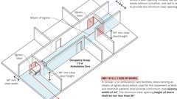
Width of Doors in I-2 / Ambulatory Care (Stretchers) (CA)
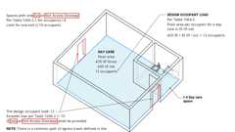
Group I-4 Exits
Locking Arrangements in Educational Occupancies
Occupancy Groups of the Building Code
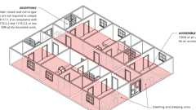
Group I-2 Rehabilitations Facilities
Building products (2)
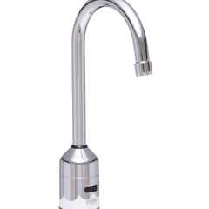
AquaSense® 5-3/8 in. Gooseneck Sensor Faucet With Gear-driven Ceramic Cartridge - ZG6920
Zurn

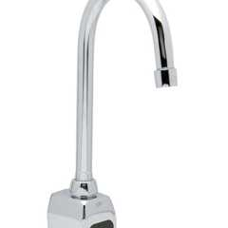
AquaSense® Wall Mount 5-3/8 in. Gooseneck Sensor Faucet With Gear-driven Ceramic Cartridge - ZG6922
Zurn

308.1 Institutional Group I
Institutional Group I occupancy includes, among others, the use of a building or structure, or a portion thereof, in which care or supervision is provided to persons who are or are incapable of self-preservation without physical assistance or in which persons are detained for penal or correctional purposes or in which the liberty of the occupants is restricted. Institutional occupancies shall be classified as Group I-2, I-3 or I-4. Restraint shall not be permitted in any building except in Group I-2 occupancies constructed for such use in accordance with Section 407.1.1 and Group I-3 occupancies constructed for such use in accordance with Section 408.1.2.
Where occupancies house both ambulatory and nonambulatory persons, the more restrictive requirements shall apply.
308.2 Institutional Group I-1
Diagram
Not used. (See Group R-2.1 Section 310.1.)
UpCodes Diagram (1)
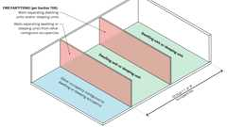
Fire Partitions: Dwelling and Sleeping Units
308.3 Institutional Group I-2
Diagram
Institutional Group I-2 occupancy shall include buildings and structures used for medical care on a 24-hour basis for more than five persons who are incapable of self-preservation or classified as nonambulatory or bedridden. This group shall include, but not be limited to, the following:
- Foster care facilities
- Detoxification facilities
- Hospitals
- Nursing homes
- Psychiatric hospitals
UpCodes Diagrams (10)
Width of Doors in I-2 / Ambulatory Care (Stretchers) (CA)
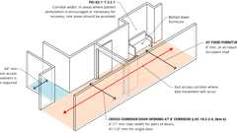
Corridor Widths in Hospitals
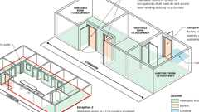
Group I-2: Direct Access to Corridor
Existing Bldgs: Min. Door Reqs. - Healthcare
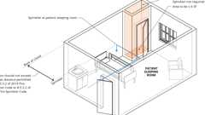
Sprinkler Reqs. - Hospital Clothes Closets
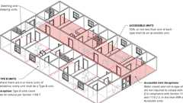
Group I-2 Nursing Homes
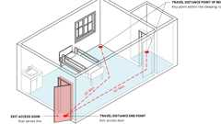
Distance of Travel within Group I-2 Sleeping Room
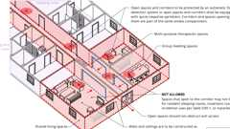
Nursing Home Areas Open to Corridors
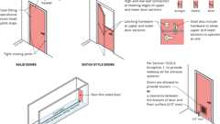
Non-rated Doors in Group I-2 Corridors
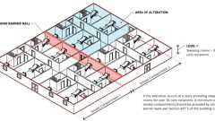
Alterations: Smoke Compartments in Group I-2
308.3.1 Five or Fewer Persons Receiving Medical Care
A facility with five or fewer persons receiving medical care shall be classified as Group R-3.1 or shall comply with the California Residential Code provided an automatic sprinkler system is installed in accordance with Section 903.3.1.3 of this code or Section R309 of the California Residential Code.
308.3.2 Reserved
308.4 Institutional Group I-3
Diagram
Institutional Group I-3 occupancy shall include buildings or portions of buildings and structures that are inhabited by more than five persons who are under restraint or security. A Group I-3 facility is occupied by persons who are generally incapable of self-preservation due to security measures not under the occupants' control which includes persons restrained. This group shall include, but not be limited to, the following:
- Correctional centers
- Correctional hospitals
- Correctional nursing facilities
- Correctional mental health facilities
- Correctional treatment centers
- Courthouse holding facility
- Detention centers
- Detention treatment room
- Jails
- Juvenile halls
- Prerelease centers
- Prisons
- Reformatories
- Secure interview rooms
- Temporary holding facility
Buildings of Group I-3 shall be classified as one of the occupancy conditions specified in Sections 308.4.1 through 308.5.8 and shall comply with Section 408.
UpCodes Diagrams (2)
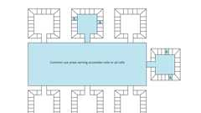
Detention & Correctional Facilities - Common Use Areas
Guardrail Openings - Exceptions 3 & 4
Building product (1)
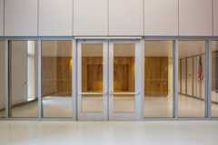
GPX® Ballistic
SaftiFirst

308.4.1 Condition 1
This occupancy condition shall include buildings in which free movement is allowed from sleeping areas, and other spaces where access or occupancy is permitted, to the exterior via means of egress without restraint. A Condition 1 facility is permitted to be constructed as Group R.
308.4.2 Condition 2
This occupancy condition shall include buildings in which free movement is allowed from sleeping areas and any other occupied smoke compartment to one or more other smoke compartments. Egress to the exterior is impeded by locked exits.
308.4.3 Condition 3
This occupancy condition shall include buildings in which free movement is allowed within individual smoke compartments, such as within a residential unit composed of individual sleeping units and group activity spaces, where egress is impeded by remote-controlled release of means of egress from such a smoke compartment to another smoke compartment.
308.4.4 Condition 4
This occupancy condition shall include buildings in which free movement is restricted from an occupied space. Remote-controlled release is provided to permit movement from sleeping units, activity spaces and other occupied areas within the smoke compartment to other smoke compartments.
308.4.5 Condition 5
This occupancy condition shall include buildings in which free movement is restricted from an occupied space. Staff-controlled manual release is provided to permit movement from sleeping units, activity spaces and other occupied areas within the smoke compartment to other smoke compartments.
308.4.6 Condition 6
This occupancy condition shall include buildings containing only one temporary holding facility with six or fewer persons under restraint or security where the building is protected throughout with a monitored automatic sprinkler system installed in accordance with Section 903.3.1.1 and where the temporary holding facility is protected throughout with an automatic fire alarm system with notification appliances. A Condition 6 building shall be permitted to be classified as a Group B occupancy.
308.4.7 Condition 7
This occupancy condition shall include buildings containing only one temporary holding facility with nine or less persons under restraint or security where limited to the first or second story, provided the building complies with Section 408.1.2.6. A Condition 7 building shall be permitted to be classified as a Group B occupancy.
308.4.8 Condition 8
This occupancy condition shall include buildings containing not more than four secure interview rooms located within the same fire area where not more than six occupants under restraint are located in the same fire area. A Condition 8 building shall be is permitted to be classified as a Group B occupancy, provided the requirements in Section 408.1.2.7 are met.
308.4.9 Condition 9
This occupancy condition shall include buildings where the use of the building is for correctional medical care or correctional mental health care.
308.5 Institutional Group I-4, Day Care Facilities
Diagram
Institutional Group I-4 occupancy shall include buildings and structures occupied by more than six clients of any age who receive custodial care for fewer than 24 hours per day by persons other than parents or guardians; relatives by blood, marriage or adoption; and in a place other than the home of the clients cared for. This group shall include, but not be limited to, the following:
- Adult day care
- Child day care (not classified as Group E)
UpCodes Diagrams (2)
Locking Arrangements in Educational Occupancies
Group I-4 Exits
308.5.1 Classification as Group E
A child day care facility that provides care for more than six but not more than 100 children under 36 months of age, where the rooms in which the children are cared for are located on a level of exit discharge serving such rooms and each of these child care rooms has an exit door directly to the exterior, shall be classified as Group E.
308.5.1.1 Special Provisions
See Section 452.1.4 of the California Building Code for child care locations above or below the first story.
308.5.2 Within a Place of Religious Worship
Rooms and spaces within places of religious worship providing such care during religious functions shall be licensed by the California State Department Health Services as required by Health and Safety Code Division 2 Chapter 3.5.
308.5.3 Five or Fewer Persons Receiving Care
A facility having five or fewer persons receiving custodial care shall be licensed pursuant to Health and Safety Code Division 2 Chapter 3.5 or 3.6.
308.5.4 Six or Fewer Persons Receiving Care in a Dwelling Unit
A facility such as the above within a dwelling unit and having six or fewer persons receiving custodial care shall be classified as a Group R-3 occupancy, where occupants are not capable of responding to an emergency situation without physical assistance from the staff shall be classified as a Group I-4.
Section 309 Mercantile Group M
Diagram
UpCodes Diagrams (13)
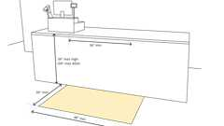
Sales and Service Counters - Parallel Approach (CA)
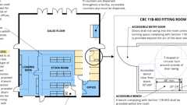
Retail (CA 11B)
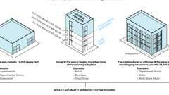
Sprinklers: Group M
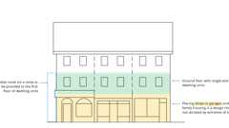
Covered Dwelling Units over Shops and Garages
Automatic Doors: When Required
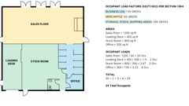
Occupant Loads: Retail
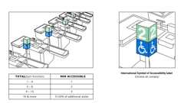
Check-Out Aisles
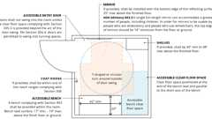
Fitting Rooms (ADA)
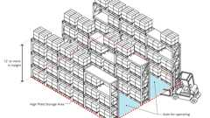
High Piled Storage (definition)
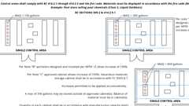
Hazmat in Group M (2024)
Show 3 more
Building products (7)
Integrated Plumbing System / Aerofoil - TSL.IPS.AERO
The Splash Lab

Lumashelf Integrated Sink - TSL.LUMA
The Splash Lab

Monolith A Series - TSL.MON.A
The Splash Lab

Monolith B Series - TSL.MON.B
The Splash Lab

Monolith C Series - TSL.MON.C
The Splash Lab

Monolith D Series - TSL.MON.D
The Splash Lab

The Aerofoil Basin - TSL.AERO
The Splash Lab

309.1 Mercantile Group M
Mercantile Group M occupancy includes, among others, the use of a building or structure or a portion thereof for the display and sale of merchandise, and involves stocks of goods, wares or merchandise incidental to such purposes and where the public has access. Mercantile occupancies shall include, but not be limited to, the following:
- Department stores
- Drug stores
- Greenhouses for display and sale of plants that provide public access
- Markets
- Motor fuel-dispensing facilities
- Retail or wholesale stores
- Sales rooms
309.2 Quantity of Hazardous Materials
Diagram
The aggregate quantity of nonflammable solid and nonflammable or noncombustible liquid hazardous materials stored or displayed in a single control area of a Group M occupancy shall not exceed the quantities in Table 414.2.5.1.
UpCodes Diagram (1)
Primary
Hazmat in Group M (2024)
309.3 Motor Fuel-Dispensing Facilities
Motor fuel-dispensing facilities shall comply with Section 406.7.
Section 310 Residential Group R
Diagram
UpCodes Diagrams (25)
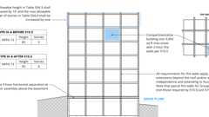
Podiums: Type IIIA Height Increase (2021)
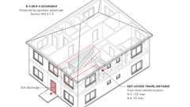
Exit Access Travel Distance: R-3 and R-4
Automatic Doors: When Required
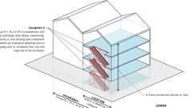
Exit Access Stair: Enclosure (Ex. 2)
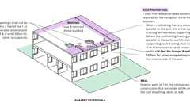
Parapets - Exception 4
Multiple Occupancy Building: Design Occupant Load
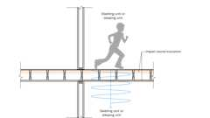
Structure-Borne Sound
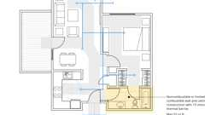
Sprinklers: Bathroom Exemption (NFPA 13)
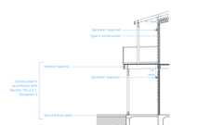
NFPA 13R Sprinklers: Balconies and Decks
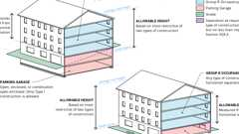
Podiums: Parking Beneath Group R
Show 15 more
Building products (2)
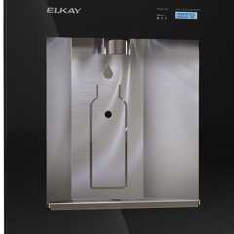
Liv® Built-in Filtered Refrigerated Water Dispenser Remote Chiller Midnight - LBWD06BKK
Elkay

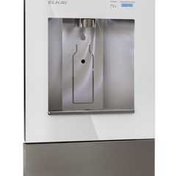
Liv® Built-in Filtered Water Dispenser Non-refrigerated Aspen White - LBWD00WHC
Elkay

310.1 Residential Group R
Residential Group R includes, among others, the use of a building or structure, or a portion thereof, for sleeping purposes when not classified as an Institutional Group I or when not regulated by the California Residential Code. Group R occupancies not constructed in accordance with the California Residential Code as permitted by Sections 310.4.1 and 310.4.2 shall comply with Section 420.
Building products (16)
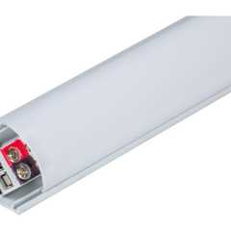
600 Lumens/Ft. Angled Linear Fixture, Tunable-White, 2700K–5000K - LT-P3
Task Lighting and Power

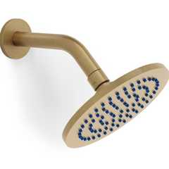
Elements 6" Diameter Showerhead With Arm and Flange
Watermark Designs

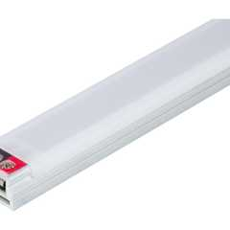
Flat Profile Linear Fixtures - Single-White - LS-P7
Task Lighting and Power

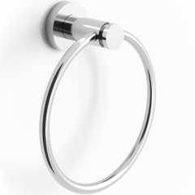
Loft 6" Diameter Wall Mounted Towel Ring
Watermark Designs

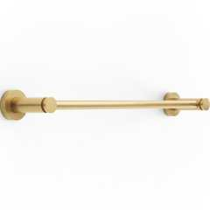
Loft Wall Mounted 18" Center-to-Center Towel Bar
Watermark Designs

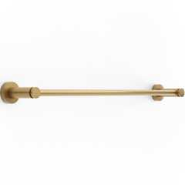
Loft Wall Mounted 24" Center-to-Center Towel Bar
Watermark Designs

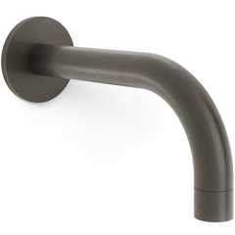
Loft Wall Mounted Bath Spout
Watermark Designs

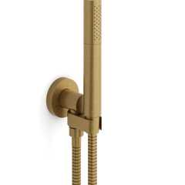
Loft Wall Mounted Hand Shower Set With Slim Hand Shower
Watermark Designs

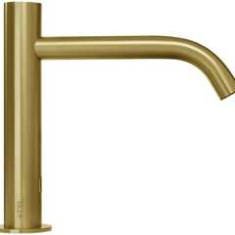
Radius Deck Mounted Sensor Faucet / Large - TSL.960
The Splash Lab

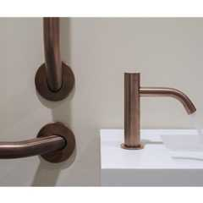
Radius Deck Mounted Sensor Faucet / Small - TSL.990
The Splash Lab

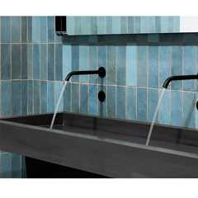
Radius Sensor Faucet / Large - TSL.882
The Splash Lab

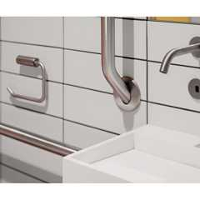
Radius Sensor Faucet / Small - TSL.884
The Splash Lab

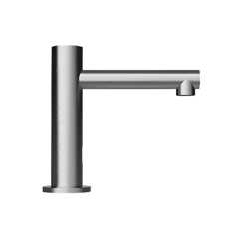
Straight Spout Faucet / Small - TSL.980
The Splash Lab

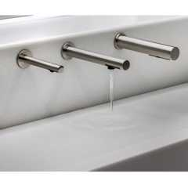
The Channel Faucet - TSL.C.050
The Splash Lab

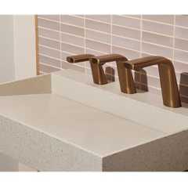
The Ribbon Faucet - TSL.R.020
The Splash Lab

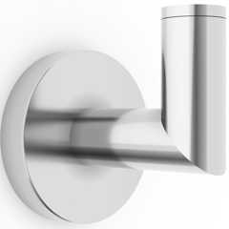
Titanium Wall Mounted Robe Hook
Watermark Designs

310.2 Residential Group R-1
Diagram
Residential Group R-1 occupancies containing sleeping units or more than two dwelling units where the occupants are primarily transient in nature, including:
- Boarding houses (transient) with more than 10 occupants
- Congregate residences (transient) with more than 10 occupants
- Hotels (transient)
- Motels (transient)
- [HCD 1] Efficiency dwelling units (transient)
UpCodes Diagrams (5)
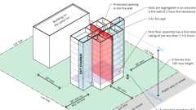
Group R-1 & R-2 Bldgs Type IIA - Height Increase Pt 1
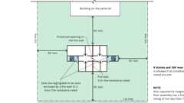
Group R-1 & R-2 Bldgs Type IIA - Height Increase Pt 2
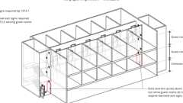
Exit Signs in R-1 Occupancies
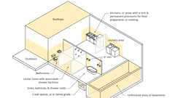
GFCI locations - Other than Dwellings
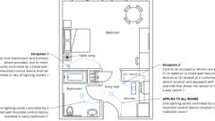
Lighting Outlets - Guest Rooms / Suites
310.3 Residential Group R-2
Diagram
Residential Group R-2 occupancies containing sleeping units or more than two dwelling units where the occupants are primarily permanent in nature, including:
- Apartment houses
  - Large family child care
  - Small family child care
- Congregate living facilities (nontransient) with more than 16 occupants
  - Boarding houses (nontransient)
  - Convents
  - Dormitories
  - Emergency services living quarters
  - Fraternities and sororities
  - Monasteries
- Hotels (nontransient)
- Live/work units
- Motels (nontransient)
- Vacation timeshare properties
- [HCD 1] Efficiency dwelling units (transient)
UpCodes Diagrams (24)
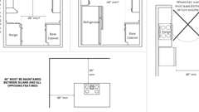
Kitchen Countertop Clearances (CBC 11A)
Group R-1 & R-2 Bldgs Type IIA - Height Increase Pt 1
Group R-1 & R-2 Bldgs Type IIA - Height Increase Pt 2
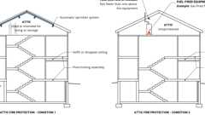
Attic Fire Protection - Condition 1 & 2 (NFPA 13R)
Covered Dwelling Units over Shops and Garages
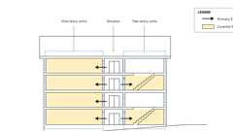
Covered Multi-Family Dwellings with Elevators
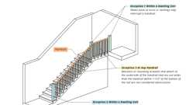
Handrail Continuity - Excpt. 1-3
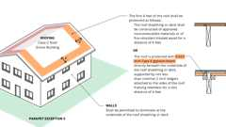
Parapets - Exception 5
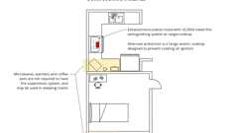
Cooking Facilities: R-2 Dorms
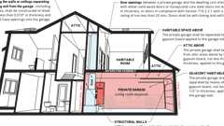
Private Garage Separation from Dwelling Units (BC)
Show 14 more
Building products (9)
600 Lumens/Ft. Angled Linear Fixture, Tunable-White, 2700K–5000K - LT-P3
Task Lighting and Power

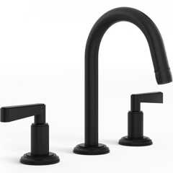
Anika Deck Mounted 3-Hole Lavatory Set
Watermark Designs

Flat Profile Linear Fixtures - Single-White - LS-P7
Task Lighting and Power

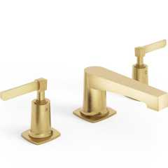
H-Line 3-Hole Deck Mounted Widespread Lavatory Set
Watermark Designs

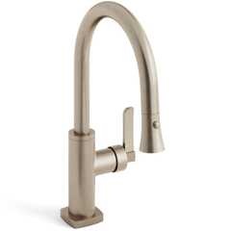
H-Line Low Gooseneck Kitchen Faucet With Pull Down Spray
Watermark Designs

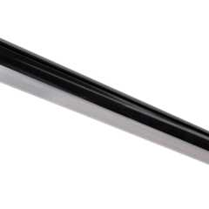
Lighted Closet Rod - Tunable-white, Aluminum Profile, Frosted Lens, White - LCR-T
Task Lighting and Power

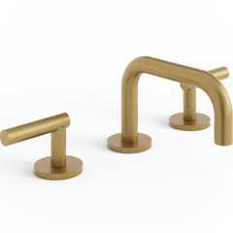
Loft Deck Mounted 3-Hole Lavatory Set
Watermark Designs

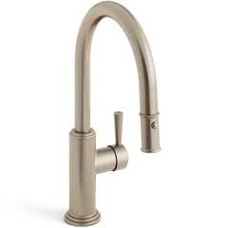
Stratford 1 Hole Gooseneck Kitchen Faucet With Pull Down Spray
Watermark Designs

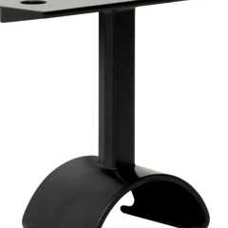
Top-Mounted Support, Lighted Closet Rod - L-LCR-HS
Task Lighting and Power

310.3.1 Residential Group R-2.1
Diagram
Residential Group R-2.1 occupancies shall include buildings, structures or parts thereof housing clients, on a 24-hour basis, who because of age, mental disability or other reasons, live in a supervised residential environment that provides personal care services.
This occupancy may contain more than six nonambulatory and/or bedridden clients. (See Section 435 Special Provisions for Licensed 24-Hour Care Facilities in a Group R-2.1, R-3.1 or R-4 Occupancy). This group shall include, but not be limited to, the following:
- Assisted living facilities such as:
  - Residential care facilities,
  - Residential care facilities for the elderly (RCFEs),
  - Adult residential facilities,
  - Congregate living health facilities,
  - Group homes,
  - Residential care facilities for the chronically ill,
  - Congregate living health facilities for the terminally ill.
- Social rehabilitation facilities such as:
  - Halfway houses,
  - Community correctional centers,
  - Community treatment programs,
  - Work furlough programs,
  - Alcoholism or drug abuse recovery or treatment facilities.
UpCodes Diagram (1)
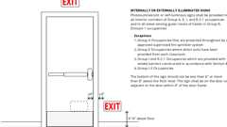
Low-Level Exit Signs (CA)
310.3.2 Residential Group R-2.2 (CDCR Only)
Residential occupancies operated by CDCR in a community located facility that provides housing and community-based program services for nontransient ambulatory participants in a nonlicensed facility with 24/7 supervision.
310.4 Residential Group R-3
Diagram
Residential Group R-3 occupancies where the occupants are primarily permanent in nature and not classified as Group R-1, R-2.1, R-2.2, R-3.1, R-4 or I, including:
- Buildings that do not contain more than two dwelling units
- Care facilities that provide accommodations for five or fewer persons receiving care
- Congregate residences (nontransient) with 16 or fewer occupants
  - Boarding houses (nontransient)
  - Convents
  - Dormitories
  - Emergency services living quarters
  - Fraternities and sororities
  - Monasteries
- Congregate residences (transient) with 10 or fewer occupants
- [HCD 1] Efficiency dwelling units
- Boarding houses (transient)
- Adult care facilities that provide accommodations for six or fewer clients of any age for less than 24 hours
- Licensing categories that may use this classification include Adult Day Programs
- Alcoholism or drug abuse recovery homes (ambulatory only)
- Child-care facilities that provide accommodations for six or fewer clients of any age for less than 24 hours
- Licensing categories that may use this classification include, but are not limited to:
  - Day-Care Center for Mildly Ill Children,
  - Infant Care Center,
  - School Age Child Day-Care Center
- Family Day-Care Homes that provide accommodations for 14 or fewer children, in the provider's own home for less than 24-hours
- Adult care and child-care facilities that are within a single family home are permitted to comply with the California Residential Code
- Lodging houses with five or fewer guest rooms
UpCodes Diagrams (14)
Exit Access Travel Distance: R-3 and R-4
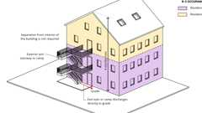
Exterior Exit Stairway and Ramp Protection - Exception 4
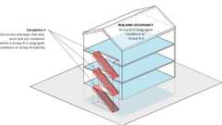
Exit Access Stair: Enclosure (Ex. 3)
Handrail Continuity - Excpt. 1-3
Parapets - Exception 5
Multiple Occupancy Building: Design Occupant Load
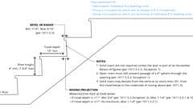
Stair Riser / Tread Depth: R-3/R-2 Exception
Private Garage Separation from Dwelling Units (BC)
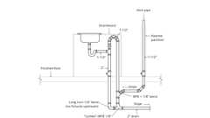
Venting for Island Fixtures (UPC)
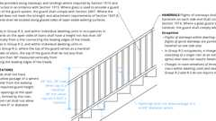
Guards At Stairs (Res)
Show 4 more
Building products (7)
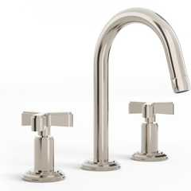
Anika Deck Mounted 3-Hole Lavatory Set
Watermark Designs

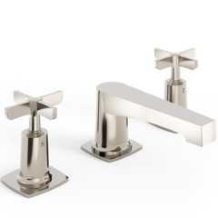
H-Line 3-Hole Deck Mounted Widespread Lavatory Set
Watermark Designs

H-Line Low Gooseneck Kitchen Faucet With Pull Down Spray
Watermark Designs

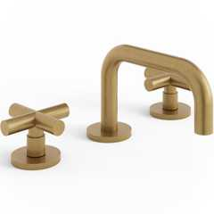
Loft Deck Mounted 3-Hole Lavatory Set
Watermark Designs

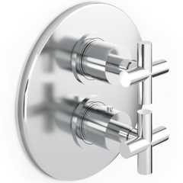
Loft Wall Mounted 7 1/2" Diameter Thermostatic Shower Trim
Watermark Designs

Stratford 1 Hole Gooseneck Kitchen Faucet With Pull Down Spray
Watermark Designs

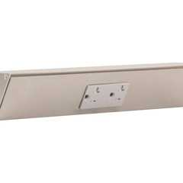
TR Series Angle Power Strip - TR
Task Lighting and Power

310.4.1 Residential Group R-3.1
This occupancy group may include facilities licensed by a governmental agency for a residentially based 24-hour care facility providing accommodations for six or fewer clients of any age. Clients may be classified as ambulatory, nonambulatory or bedridden. A Group R-3.1 occupancy shall meet the requirements for construction as defined for Group R-3, except as otherwise provided for in Section 435 Special Provisions For Licensed 24-Hour Care Facilities in a Group R-2.1, R-3.1 or R-4 Occupancy. This group may include:
- Adult residential facilities
- Congregate living health facilities
- Intermediate care facilities for the developmentally disabled habilitative
- Intermediate care facilities for the developmentally disabled nursing
- Nurseries for the full-time care of children under the age of six, but not including "infants" as defined in Chapter 2
- Residential care facilities for the elderly
- Small family homes and residential care facilities for the chronically ill
Exception: Group Homes licensed by the Department of Social Services which provide nonmedical board, room and care for six or fewer ambulatory children or children two years of age or younger, and which do not have any nonambulatory clients shall not be subject to regulations found in Section 435.
Pursuant to Health and Safety Code Section 13143 with respect to these exempted facilities, no city, county or public district shall adopt or enforce any requirement for the prevention of fire or for the protection of life and property against fire and panic unless the requirement would be applicable to a structure regardless of the special occupancy. Nothing shall restrict the application of state or local housing standards to such facilities if the standards are applicable to residential occupancies and are not based on the use of the structure as a facility for ambulatory children. For the purpose of this exception, ambulatory children do not include relatives of the licensee or the licensee's spouse.
310.4.2 Lodging Houses
Owner-occupied lodging houses with five or fewer guest rooms shall be constructed in accordance with this code or the California Residential Code, provided that facilities constructed using the California Residential Code are protected by an automatic sprinkler system installed in accordance with Section 903.3.1.3 or Section R309.1.1 of the California Residential Code.
310.5 Residential Group R-4
Diagram
Residential Group R-4 occupancy shall include buildings, structures or portions thereof for more than six ambulatory clients, but not more than 16 persons, excluding staff, who reside on a 24-hour basis in a supervised residential environment and receive custodial care. The persons receiving care are capable of self-preservation. This occupancy classification may include a maximum six nonambulatory or bedridden clients (see Section 435, Special Provisions for Licensed 24-Hour Care Facilities in a Group R-2.1, R-3.1 or R-4). Group R-4 occupancies shall meet the requirements in Section 420. This group shall include, but not be limited to, the following:
Assisted living facilities such as:
- Residential care facilities,
- Residential care facilities for the elderly (RCFE),
- Adult residential facilities,
- Congregate living health facilities,
- Group homes.
Social rehabilitation facilities such as:
- Halfway houses,
- Community treatment programs,
- Work furlough programs,
- Alcoholism or drug abuse recovery or treatment facilities.
UpCodes Diagrams (4)
Exit Access Travel Distance: R-3 and R-4
Exit Access Stair: Enclosure (Ex. 3)
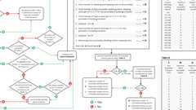
Example: Accessible Parking, R-2, R-3 and R-4
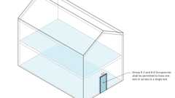
Stories with Single Exits - Condition 4
310.6 Large Family Day-Care Homes
See Section 455.
Section 311 Storage Group S
Assembly
Diagram
UpCodes Diagrams (7)
Travel Distance Increase: Group F-1 and S-1
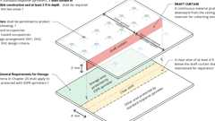
Draft Curtains in ESFR Areas
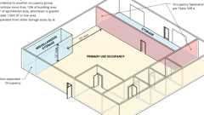
Miscellaneous Storage
Occupancy Groups of the Building Code
Multiple Occupancy Building - Occupancy Groups
Multiple Occupancy Building: Non-Separated Occupancy Requirements
Multiple Occupancy Building: Separated Occupancy Requirements
Assemblies (2)
WP 9200; 2hr, Steel Wall Panel / Girts
WP 9205; 2hr, Steel Wall Panel / Girts
Building product (1)
High Bay Bluetooth-enabled
RAB Lighting

311.1 Storage Group S
Diagram
Storage Group S occupancy includes, among others, the use of a building or structure, or a portion thereof, for storage that is not classified as a hazardous occupancy.
UpCodes Diagram (1)
Guardrail Openings - Exceptions 3 & 4
311.1.1 Accessory Storage Spaces
Diagram
A room or space used for storage purposes that is accessory to another occupancy shall be classified as part of that occupancy.
UpCodes Diagrams (3)
Cumulative Occ. Loads: Intervening Spaces/Accessory Areas
Accessory Occupancies
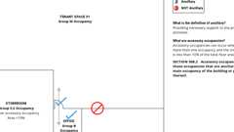
Accessory Occ.: Example
311.1.2 Combustible Storage
Diagram
High-piled stock or rack storage, or attic, under-floor and concealed spaces used for storage of combustible materials, shall be in accordance with Section 413.
UpCodes Diagram (1)
High Piled Storage (definition)
311.2 Moderate-Hazard Storage, Group S-1
Diagram
Storage Group S-1 occupancies are buildings occupied for storage uses that are not classified as Group S-2, including, but not limited to, storage of the following:
- Aerosol products, Levels 2 and 3, aerosol cooking spray, plastic aerosol 3 (PA3)
- Aircraft hangar (storage and repair)
- Bags: cloth, burlap and paper
- Bamboos and rattan
- Baskets
- Belting: canvas and leather
- Beverages over 20-percent alcohol content
- Books and paper in rolls or packs
- Boots and shoes
- Buttons, including cloth covered, pearl or bone
- Cardboard and cardboard boxes
- Clothing, woolen wearing apparel
- Cordage
- Dry boat storage (indoor)
- Furniture
- Furs
- Glues, mucilage, pastes and size
- Grains
- Horns and combs, other than celluloid
- Leather
- Linoleum
- Lithium-ion or lithium metal batteries
- Lumber
- Motor vehicle repair garages complying with the maximum allowable quantities of hazardous materials specified in Table 307.1(1) (see Section 406.8)
- Photo engravings
- Resilient flooring
- Self-service storage facility (mini-storage)
- Silks
- Soaps
- Sugar
- Tires, bulk storage of
- Tobacco, cigars, cigarettes and snuff
- Upholstery and mattresses
- Vehicle repair garages for vehicles powered by lithium-ion or lithium metal batteries
- Wax candles
UpCodes Diagrams (3)
Travel Distance Increase: Group F-1 and S-1
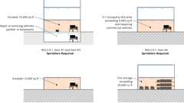
Sprinklers: Repair Garages and Tire Storage
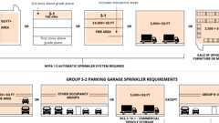
Sprinklers: Group S
311.2.1 Aircraft Hangers
Aircraft hangars used for storage or repair shall comply with Section 412.3.
311.2.2 Motor Vehicle Repair Garages
Motor vehicle repair garages shall comply with Section 406.8.
311.3 Low-Hazard Storage, Group S-2
Diagram
Storage Group S-2 occupancies include, among others, buildings used for the storage of noncombustible materials such as products on wood pallets or in paper cartons with or without single thickness divisions; or in paper wrappings. Such products are permitted to have a negligible amount of plastic trim, such as knobs, handles or film wrapping. Group S-2 storage uses shall include, but not be limited to, storage of the following:
- Asbestos
- Beverages up to and including 20-percent alcohol
- Cement in bags
- Chalk and crayons
- Dairy products in nonwaxed coated paper containers
- Dry cell batteries
- Electrical coils
- Electrical motors
- Empty cans
- Food products
- Foods in noncombustible containers
- Fresh fruits and vegetables in nonplastic trays or containers
- Frozen foods
- Glass
- Glass bottles, empty or filled with noncombustible liquids
- Gypsum board
- Inert pigments
- Ivory
- Meats
- Metal cabinets
- Metal desks with plastic tops and trim
- Metal parts
- Metals
- Mirrors
- Oil-filled and other types of distribution transformers
- Public parking garages, open or enclosed
- Porcelain and pottery
- Stoves
- Talc and soapstones
- Washers and dryers
UpCodes Diagrams (4)
Sprinklers: Group S
Podiums: Parking Beneath Group R
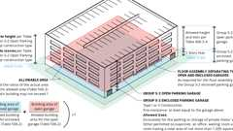
Group S-2 Enclosed Parking Garage With Group S-2 Open Parking Garage Above
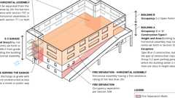
Group B or M Buildings With Group S-2 Open Parking Garage Above
311.3.1 Public Parking Garages
Diagram
Public parking garages shall comply with Section 406.4 and the additional requirements of Section 406.5 for open parking garages or Section 406.6 for enclosed parking garages.
UpCodes Diagrams (3)
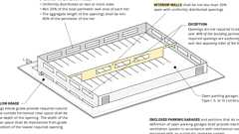
Open Parking Garage
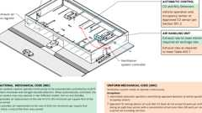
Enclosed Parking Garage Ventilation - Ducted System
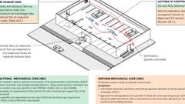
Enclosed Parking Garage Ventilation - Ductless Jet-Induction System
Section 312 Utility and Miscellaneous Group U
Diagram
UpCodes Diagrams (8)
Parapets - Exception 4
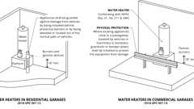
Water Heater: Garages
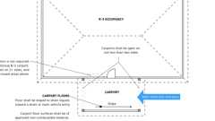
Carport Requirements
Occupancy Groups of the Building Code
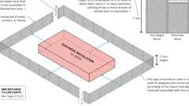
Enclosures for Outdoor Electrical Installations (≥1000V)
Multiple Occupancy Building - Occupancy Groups
Multiple Occupancy Building: Non-Separated Occupancy Requirements
Multiple Occupancy Building: Separated Occupancy Requirements
312.1 General
Buildings and structures of an accessory character and miscellaneous structures not classified in any specific occupancy shall be constructed, equipped and maintained to conform to the requirements of this code commensurate with the fire and life hazard incidental to their occupancy. Group U shall include, but not be limited to, the following:
- Agricultural buildings
- Aircraft hangars, accessory to a one- or two-family residence (see Section 412.4)
- Barns
- Carports
- Communication equipment structures with a gross floor area of less than 1,500 square feet (139 m²)
- Fences more than 7 feet (2134 mm) in height
- Grain silos, accessory to a residential occupancy
- Livestock shelters
- Private garages
- Retaining walls
- Sheds
- Stables
- Tanks
- Towers
312.1.1 Greenhouses
Greenhouses not classified as another occupancy shall be classified as Use Group U.
312.2 Private Garages and Carports
Private garages and carports shall comply with Section 406.3.
312.3 Residential Aircraft Hangars
Aircraft hangars accessory to a one- or two-family residence shall comply with Section 412.4.
Section 313 Laboratories Group L [SFM]
313.1 Group L Laboratories
[SFM] Group L occupancy includes the use of a building or structure, or a portion thereof, containing one or more laboratory suites as defined in Section 453.
Section 314 Organized Camps Group C [SFM]
314.1 Organized Camps Group C
[SFM] An organized camp is a site with programs and facilities established for the primary purpose of providing an outdoor group living experience with social, spiritual, educational or recreational objectives, for five days or more during one or more seasons of the year.

